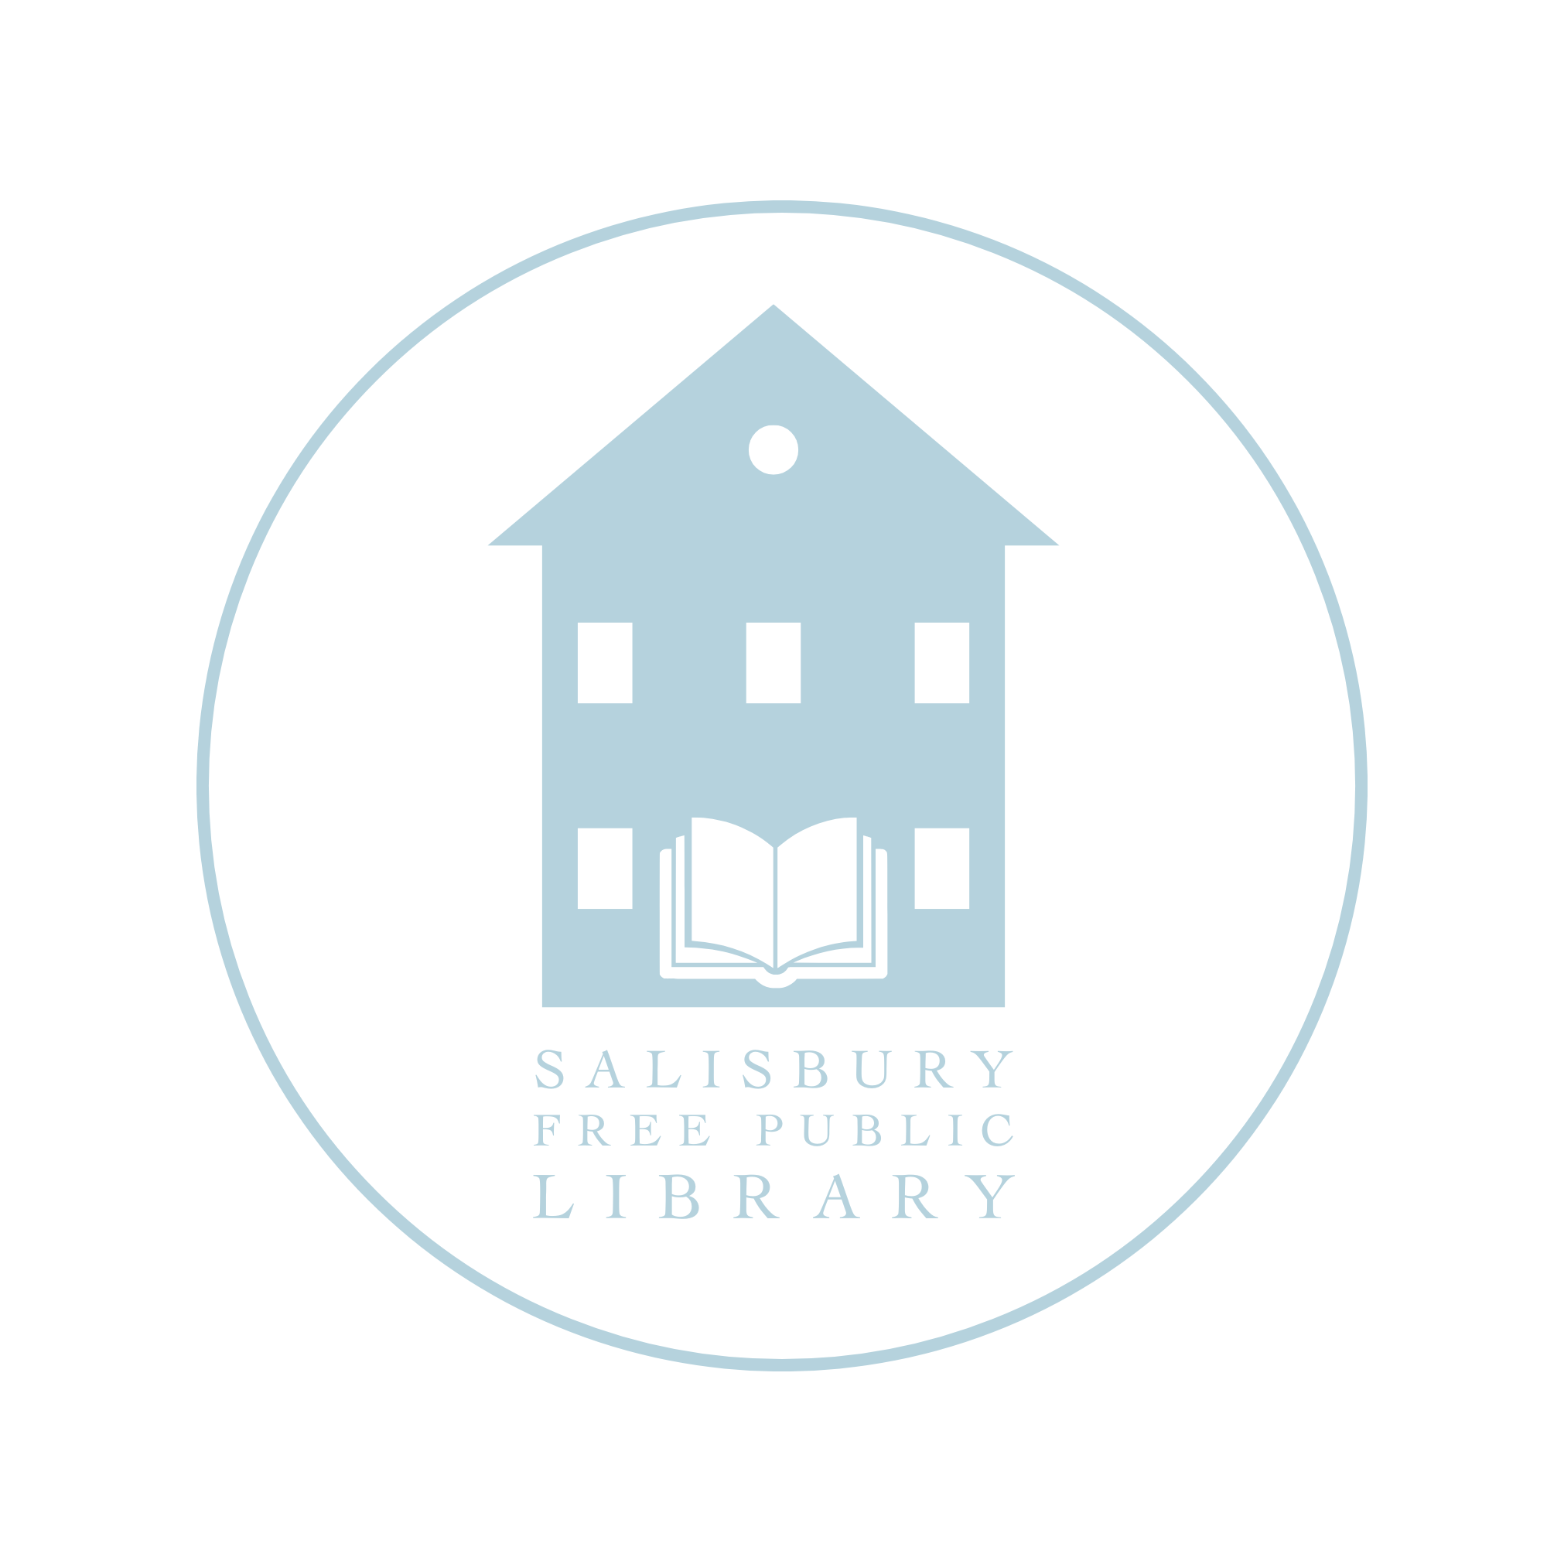

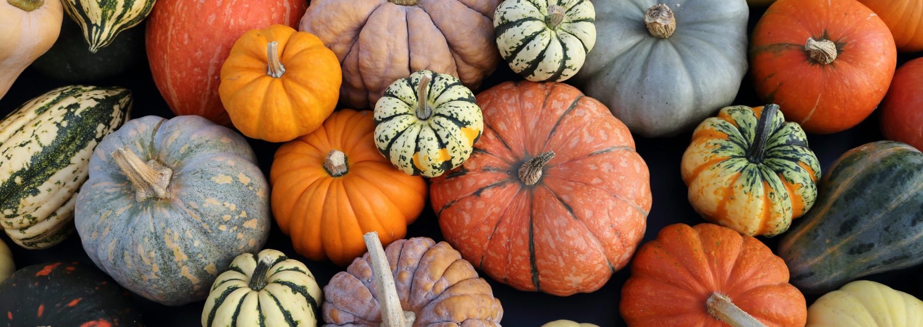
Salisbury Free Public Library
October 2026 Newsletter
During Renovation: Salisbury Meeting House
Hours: Tuesdays 10–3 • Thursdays 11–5 • Saturdays 9–12
Promoting community through information, education, dialog and celebration
We are now open Saturdays again, from 9-Noon.
📚 New Books
Coming soon from Alissa!
[New book selections and descriptions to be added.]

🎉 125th Birthday Celebration!

The Library is turning 125—and we want to celebrate with you!
Join us Saturday, October 3, at 11:00 a.m. for a special birthday celebration honoring 125 years of the Salisbury Free Public Library. The festivities will begin with a few words from Addison County Senator Ruth Hardy, followed by a look at our library's history with local historian Glenn Andres.
We'll also have photos from the past on display, and we need your help. Come take a look, see who you recognize, and if you remember when these photos were taken. There will be activities for the whole family, along with special snacks, apple cider—and, of course, Birthday Cake! 🎂 We can't wait to celebrate 125 years of our library with you!
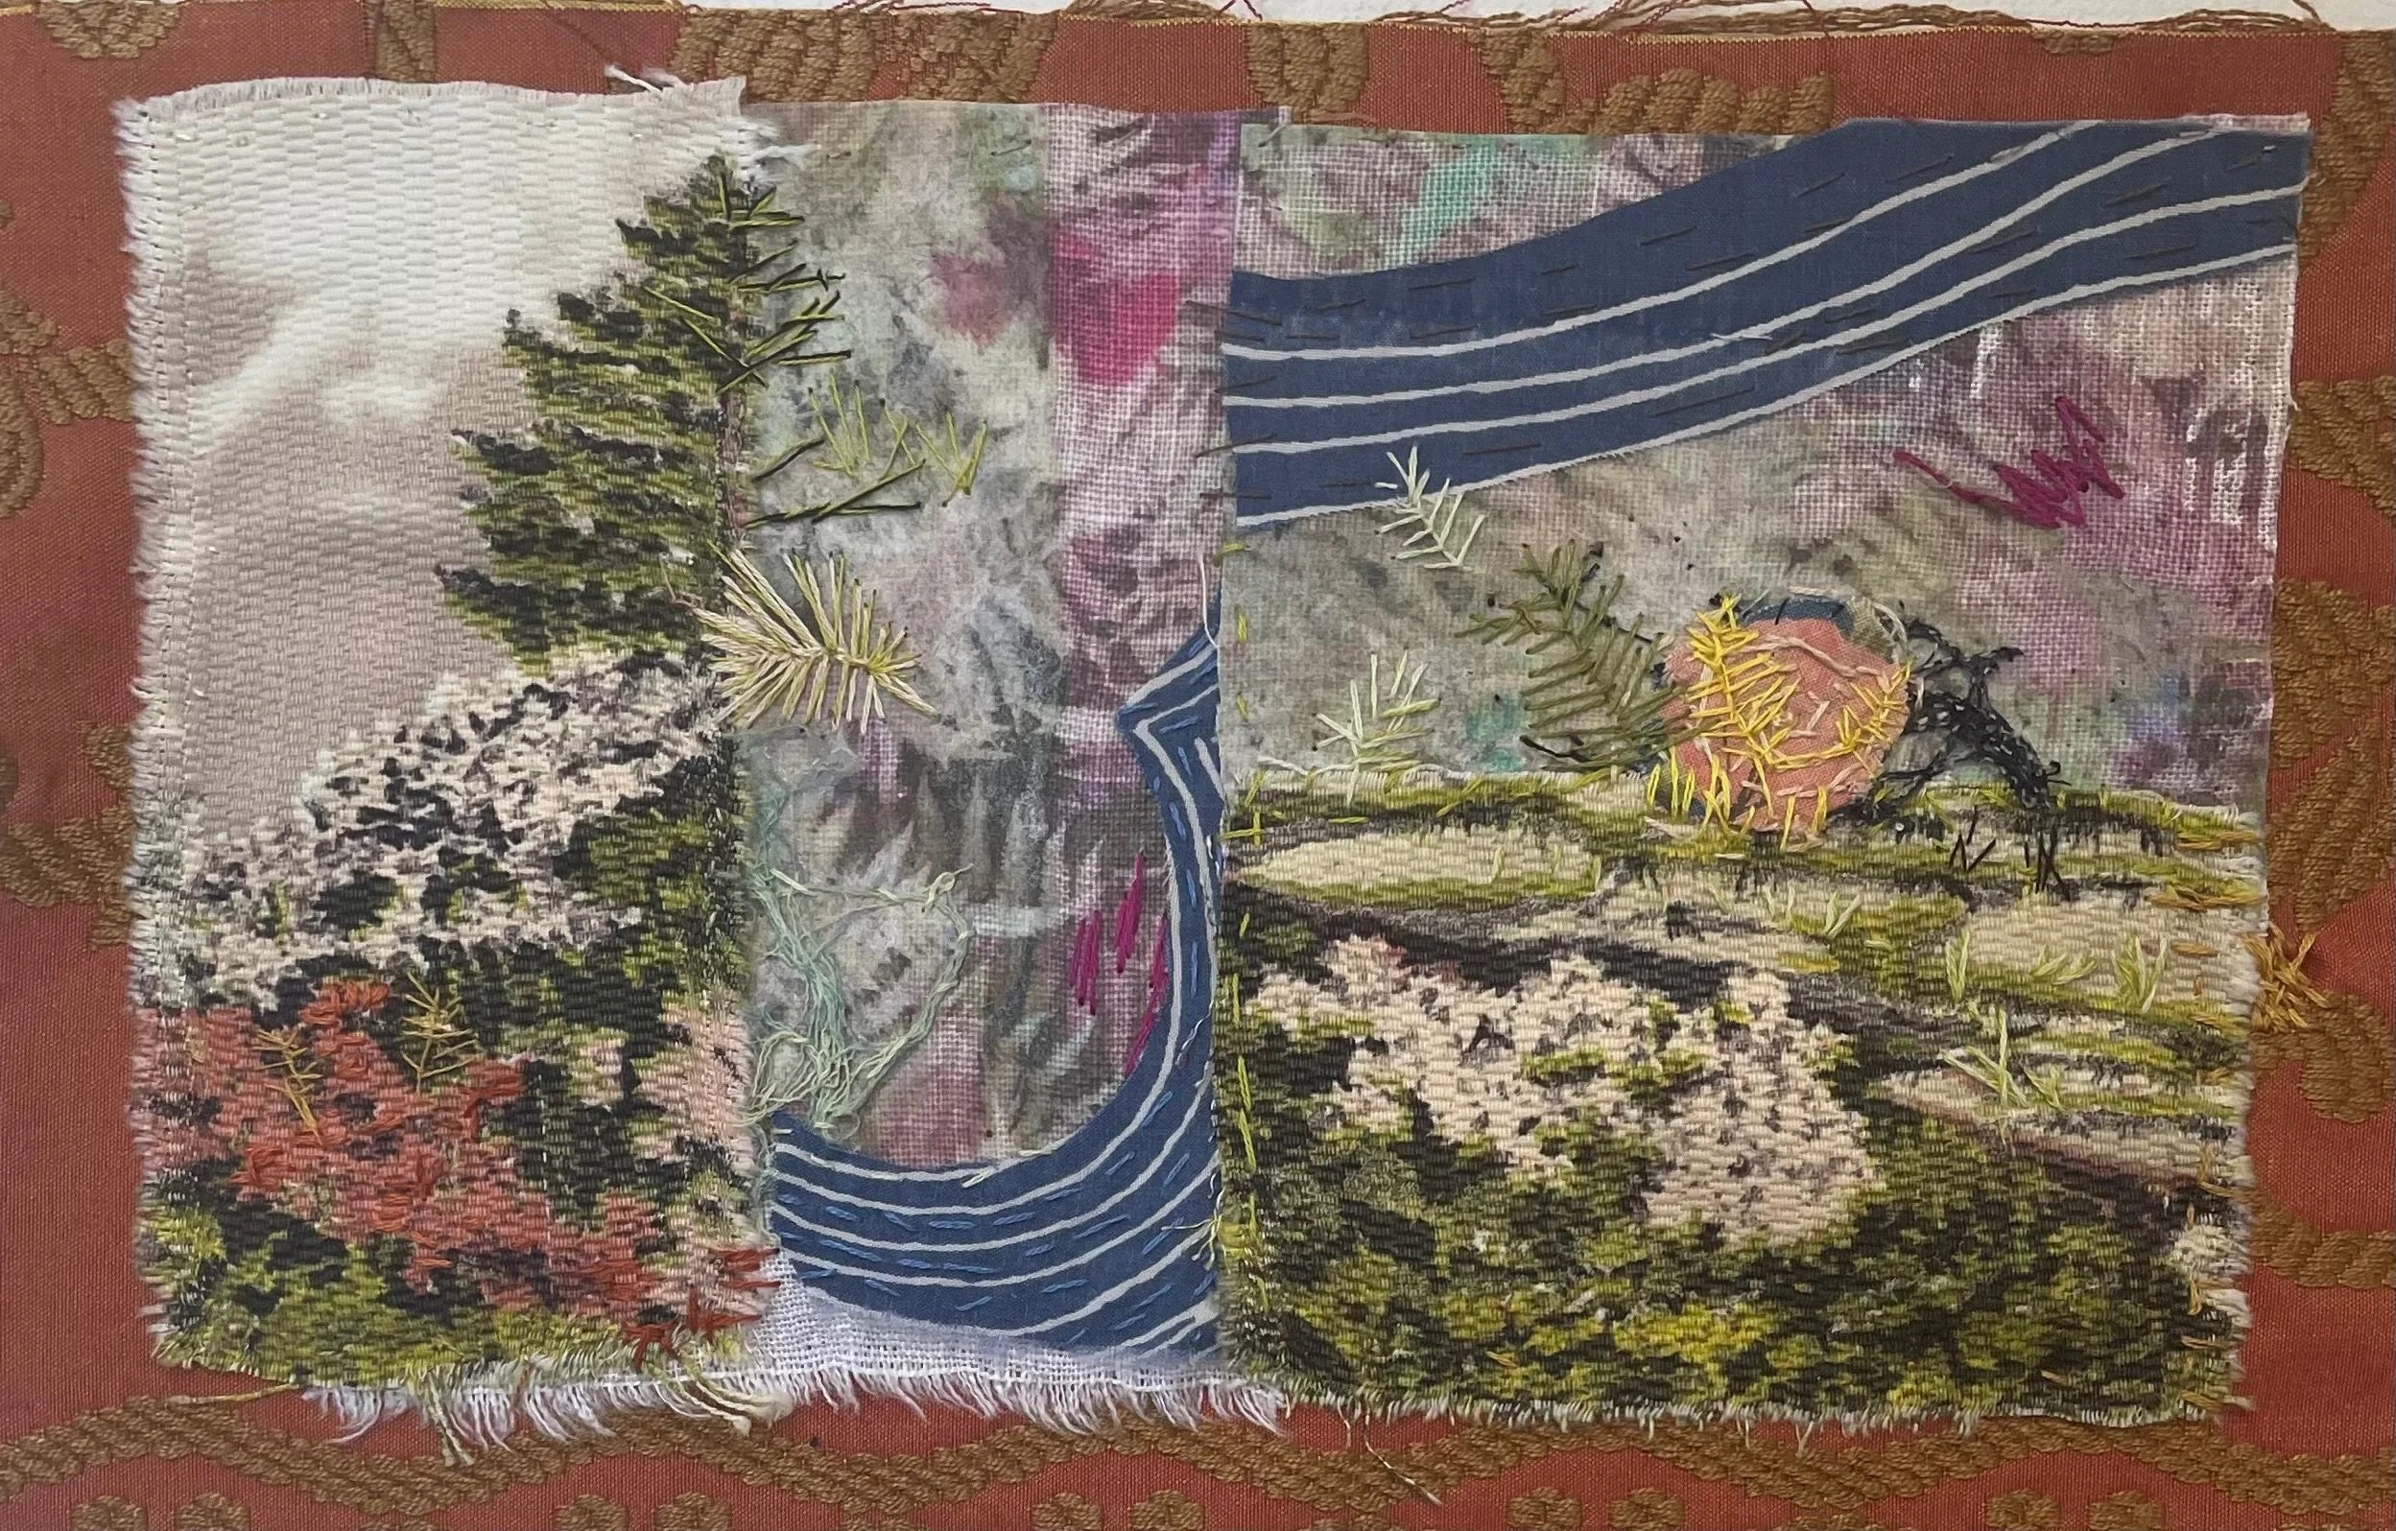
🎨 October Art Exhibit
We're excited to welcome Sarah Ashe, who will be exhibiting her wonderful sculptures and embroidered collage pieces at the library throughout October. Please join us for an Artist’s Reception on October 8th at 3 pm! Sarah's lovely 2 and 3 dimensional mixed media works use naturally dyed fabrics, cronotypes, and photographic images. She says that "much of my work has centered on social concerns: Hurricanes Katrina and Irene, death and dying, and lately the refugee crisis. The emotional engagement felt considering these issues stirs me to make visual what may be unspoken or forgotten."
🍎 Salisbury Community Cooking Club
The Salisbury Community Cooking Club is going strong. September’s gathering cooked up some serious deliciousness, including butternut squash soup, mushroom ragout, roast chicken and potatoes, and apple fritters. 🍎🍂
For October, our theme is the Flavors of Fall. The menu is still being finalized, but you can count on some delicious fall-inspired cooking and plenty of conversation — Thursday, October 15 • 6:00 p.m.
Registration is required due to space limitations- please email Gay Truax at gwtruax@gmail.com or register at the Library.
📚 Storytime and Book Giveaway with Doug Wilhelm
Doug will be back for a special story time and we will have books for children of all ages, thanks to a generous donation from the Children’s Literacy Foundation.
🛠️ Renovation Update
Everything is coming together and we’re looking forward to “going back home” to our newly renovated library.
Since our last newsletter:
1. The lift to the second floor has been installed. It's up and running and awaiting its final inspection.
2. The kitchenette is taking shape— Counters and cabinets have been installed on the second floor.
3. Interior painting is almost done and light fixtures are being installed.
📚October Book Club- Zeitoun by Dave Eggers
Dave Egger's nonfiction book tells the story of Abdulrahman Zeitoun, a Syrian-American painter and contractor who, after hurricane Katrina, traveled the flooded city in a secondhand canoe rescuing neighbors, caring for abandoned pets and distributing fresh water. He was arrested without reason or explanation by police and National Guard soldiers and held for 23 days, while forbidden to alert his family. Entertainment Weekly called it one of the best books of the decade, "a gut-wrenchingly poignant and selfless Katrina story."
📅 October Events
Every Tuesday at 10:30 a.m. — Storytime
10/1 at 4:00 p.m. — Crochet Class- postponed due to illness
10/1 at 6:00 p.m. — Tech Night
10/3 at 11:00 a.m. — 125th Birthday Celebration 🎂
10/8 at 3:00 pm — Artist’s Reception for Sarah Ashe with treats and cider
10/15 at 6:00 p.m. — Community Cooking Club: Flavors of Fall 🍎
10/17 at 10 am — Craft Circle- now once a month- with Aubrey Benner ☕🧶
10/19 at 5:00 p.m. — Library Board Meeting — All are welcome.
10/22 at 7:00 p.m. — Salisbury Book Club — Discussion of Zeitoun by Dave Eggers 📚
10/24 at 11:00 am — Special story time and book giveaway with Doug Wilhelm
10/24 Time TBD — Salisbury School Trunk or Treat

Salisbury Free Public Library
During Renovation: Downstairs at the Salisbury Meeting House
Promoting community through information, education, dialog and celebration

